

Universidad Tecnológica de Panamá

Centro Regional de Veraguas

Facultad de Ingeniería Eléctrica

Licenciatura en Ingeniería Electromecánica

Asignatura:

Cálculo Diferencial e Integral I

Taller N°1

Límites - Continuidad

Facilitador:

Dr. Jorge E. Hernández U.

Grupo:

4IE401

Fecha de entrega:

24 de abril

Primer semestre

2017

PROBLEMAS













 

 

DESARROLLO





|  |  |  |  |  |
| --- | --- | --- | --- | --- |
| x | 4 | 3.1 | 3.01 | 3.001 |
| f(x) | 1.41 | 0.44 | 0.14 | 0.014 |

|  |  |  |  |  |
| --- | --- | --- | --- | --- |
| x | 2 | 2.9 | 2.99 | 2.999 |
| f(x) | N. E | N. E | N. E | N. E |





|  |  |  |  |  |
| --- | --- | --- | --- | --- |
|  | 3 | 2.8 | 2.5 | 2.4 |
|  | 0.67 | 0.62 | 0.53 | 0.49 |

|  |  |  |  |  |
| --- | --- | --- | --- | --- |
|  | 1 | 1.7 | 1.8 | 1.9 |
|  |  |  |  |  |







|  |  |  |  |  |  |
| --- | --- | --- | --- | --- | --- |
| x | 3 | 3.9 | 3.99 | 3.999 | 3.9999 |
| y | -1 | -1 | -1 | -1 | -1 |

|  |  |  |  |  |  |
| --- | --- | --- | --- | --- | --- |
| x | 5 | 4.01 | 4.001 | 4.0001 | 4.00001 |
| y | 1 | 1 | 1 | 1 | 1 |













































































































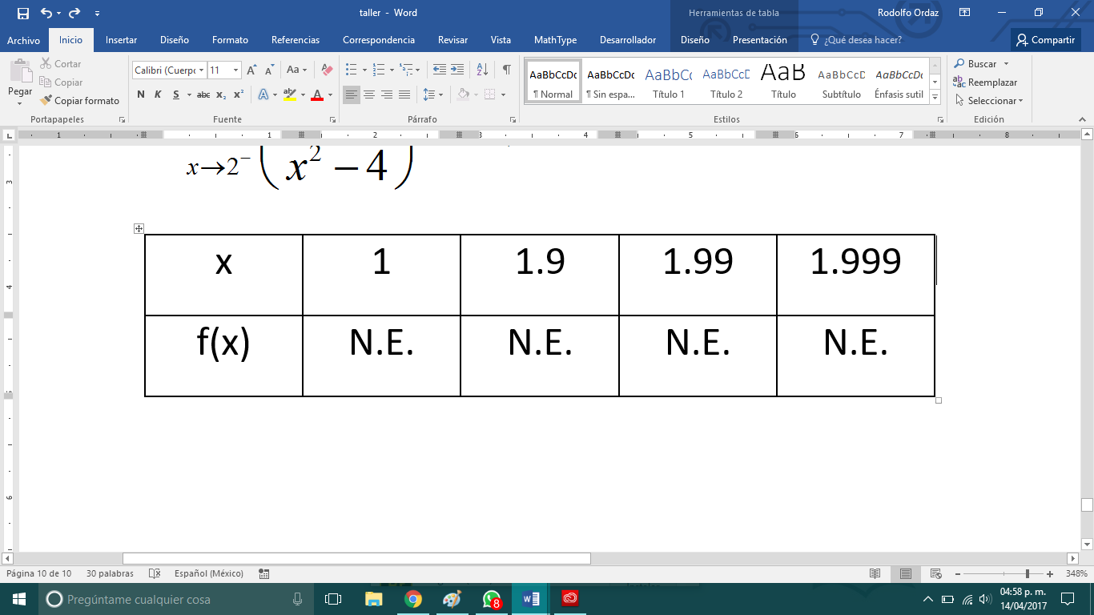







































C.V

x→ a, y→ x-a

y→0. x→ y+a































































 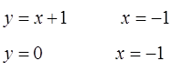































 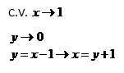

























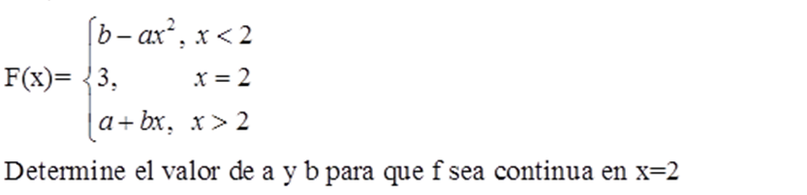









El valor de a para que f sea continua en el intervalo [0,∞]

a=8



Los valores de c y k para que f sea continua son c= -3 y k=4









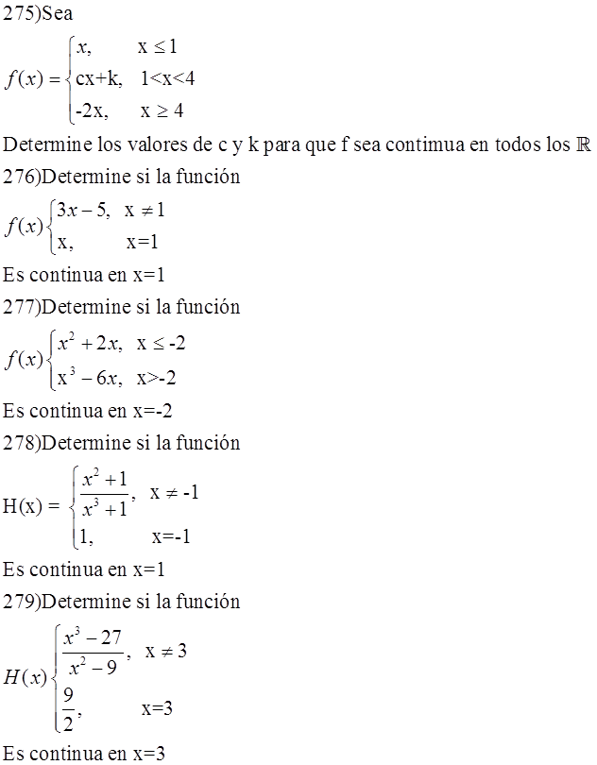







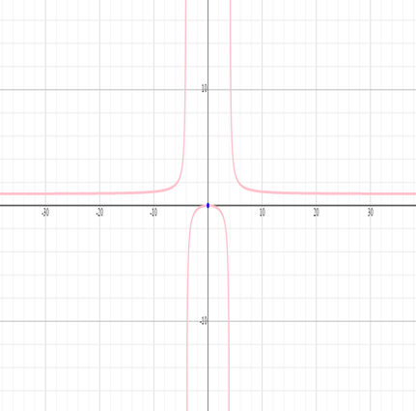

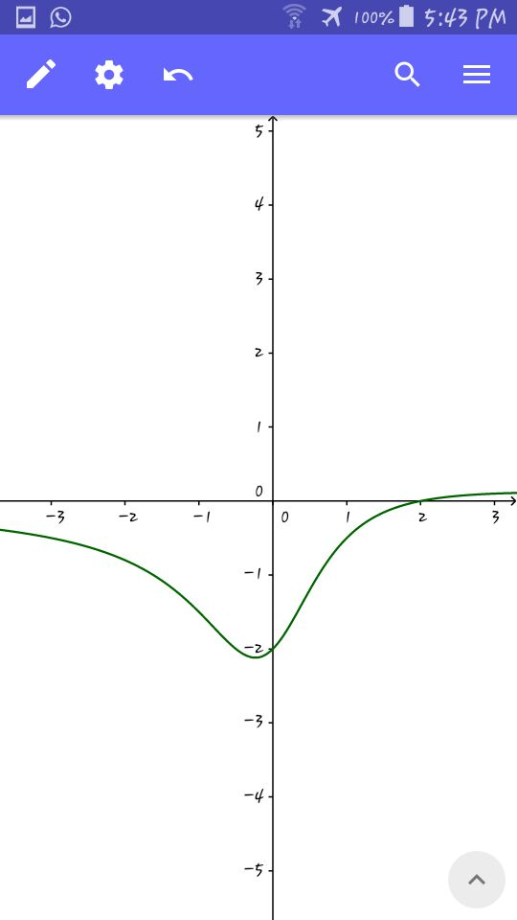

La función no es continua en x=-2



Df(x)=  A.V. (x=1)

;

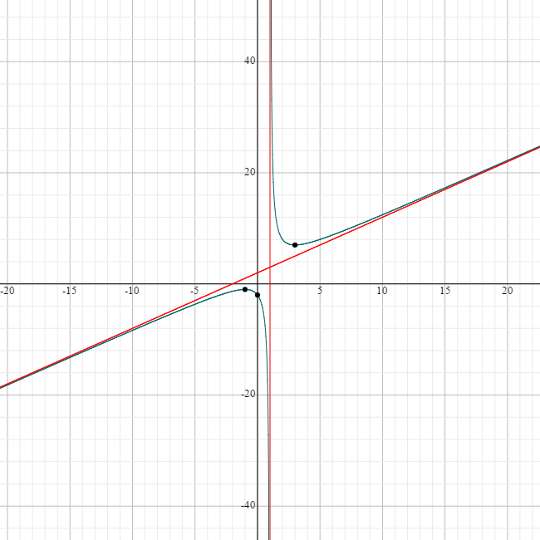

|  |  |
| --- | --- |
| **x** | **Y** |
| -5 | -3.7 |
| -3 | -2 |
| -2 | -1.3 |
| 0 | -2 |
| 2 | 8 |
| 3 | 7 |
| 5 | 8 |





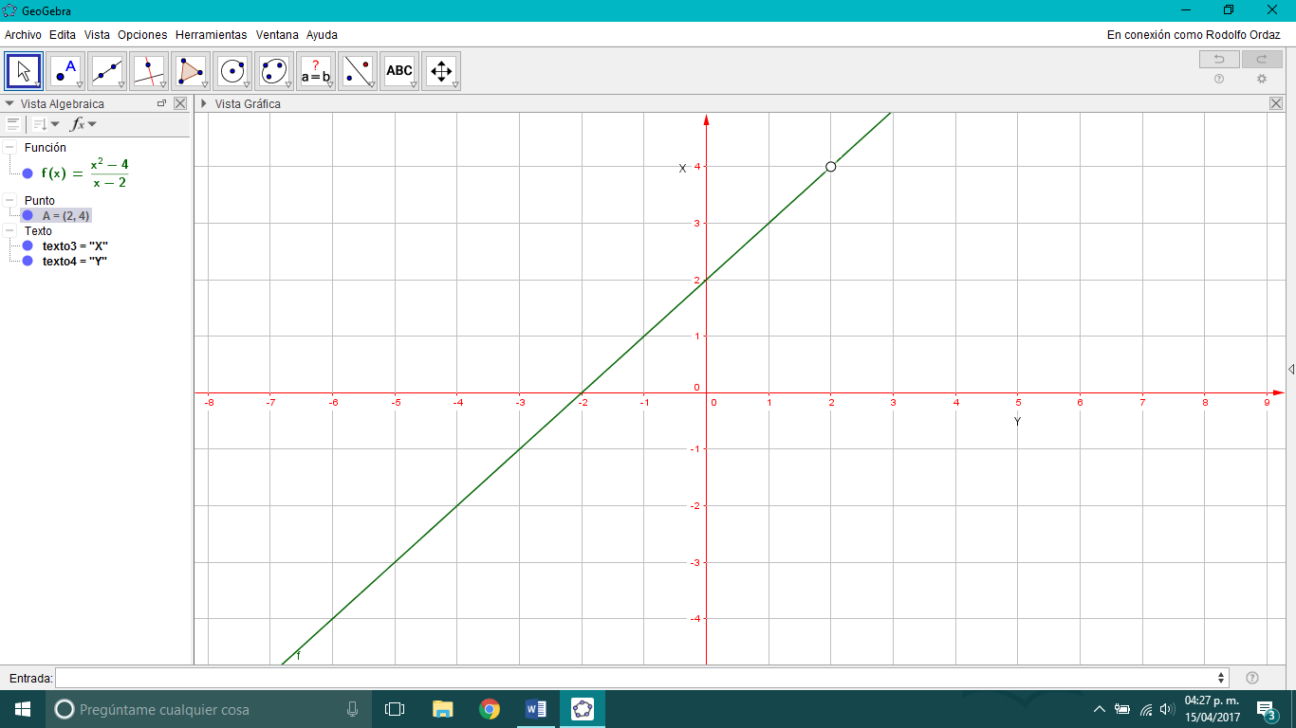

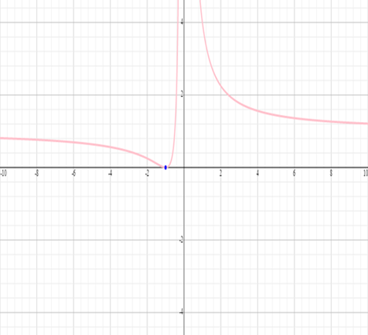

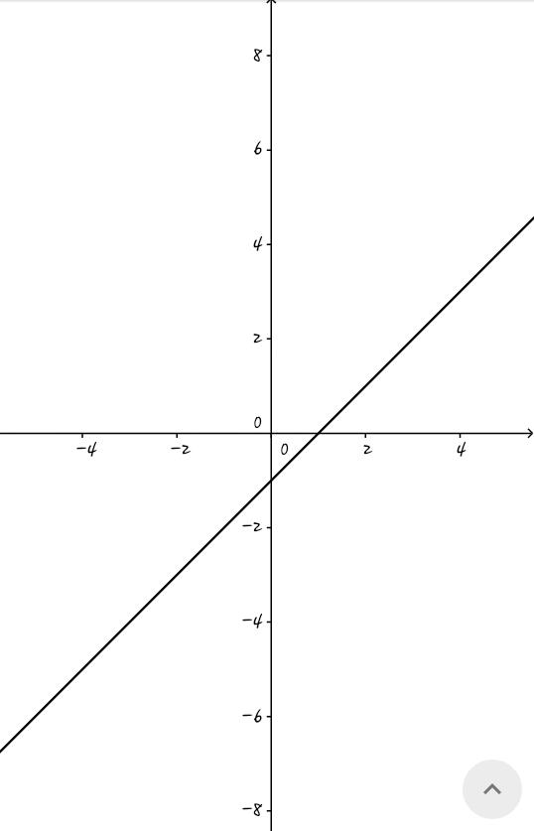





Df(x)=  Agujero:  A.V. (x=-5)

 ; 



INFORME

|  |  |
| --- | --- |
| Integrantes de Grupos | Problemas Asignados |
| Thays Gómez, Yornaikel González  Eugenio Navarro, Aldaly Pineda  Rodolfo Ordaz | 1,11,31,41,51,61,81,91,101,111  131,141,151,161,181,191,201,211  231,241251,261,281,291 |
| Davis Batista, Kerube Bonilla  Pablo de la Cruz, Tatiana González  Jorge Rodríguez | 3,13,33,43,53.63,83,93,103,113  133,143,153,163,183,193,203,  213,233,243253,263,283,293 |
| Abdiel Bordones, Marcelo Castillo  Domiciano Díaz, Christofer Del Cid  Andrés Frezac, Reinier Rodríguez | 5,15,35,45,55,65,85,95,105,115  135,145,165,185,195,205,215,  235,245,255265,285,295 |
| Javier Buglione, Cristian Camarena  Irving Manzané, José Peñalba  Carlos Rodríguez | 7,17,37,47,57,67,87,97,107,117  137,147,157,167,187,197,207,  217,237,247,257,267,287,297 |
| Keila Arcia, Jorge Cáceres  Rosenith González, Melissa Polanco  Federico Pineda | 9,19,39,49,59,69,89,99,100,119  139,149,159,169,189,199,209,  219,239,249,259,269,289,299 y 275 |
| José Barría, Joshua Bruderer  Didier Hernández, Albis López  Paul Pérez | 21,23,27,29,71,73,77,79  121,123,127,129171,173,177,179  221,223,227,229,271273,377,279 |

Coordinadores:

* Keila Arcia
* Rosenith González
* Melissa Polanco
* Jorge Rodríguez

En el grupo de la estudiante Keila Arcia hubo ciertos inconvenientes, en la realización de los problemas asignados.